NSC proposal draft from Shih-Rong.
Development of the Ribbon Synapses in the Rabbit Retina
緞帶突觸在兔子視網膜中的發育過程
ABSTRACT
The ribbon synapse is a specialized pre-synaptic structure that allows fast release of glutamate in mammalian retinas and inner eras. In the retina, ribbon synapses are found exclusively in photoreceptor and bipolar cells. During development, the maturation of ribbon synapses ensures a reliable transmission of excitatory signals from photoreceptors, through bipolar cells, to ganglion cells. Thus, the establishment of functional ribbon synapses is an important step in the retinal development. Previous research shows that ribbon synapses express early in the outer plexiform layer (OPL), and relatively late in the inner plexiform layer (IPL) between postnatal day 9 (P9) and P18 in the rabbit retina (Masland, 1977). Moreover, the temporal physiological properties of the retina ganglion cells (RGCs) are not adult-like until P20. Therefore, the purpose of this research is to correlate the spatial and temporal expression pattern of the ribbon synapses with the functional maturation of retinal circuitry at different developmental stages. This project is expected to reveal the functional role of ribbon synapses in the developing retina, and it will provide deep insights into the cellular mechanisms of circuit maturation.

SPECIFIC AIMS
To characterize the spatial and temporal expression pattern of the ribbon synapses in the developing rabbit retina. It has been reported in an electron microscopic study that the ribbon synapses in the OPL are established 2-3 days before eye-opening, and their density increases rapidly in the IPL from P9 to P18 in the rabbit retina (McArdle et al., 1977). This is consistent with our recent observation that the temporal receptive field properties of RGCs matured gradually in the same developmental period (Li and Chiao, unpublished data). To systematically examine the relationship between the expression pattern of the ribbon synapses and the physiological properties of RGCs during development, a ribbon synapse maker, Kinesin 2 (Muresan et al., 1999), will be used to visualize the its distribution and temporal variation throughout the postnatal period (P0-P30) in slice preparations using immunohistochemistry.
Hypothesis: The ribbon synapses can be detected in the OPL soon after birth and in the IPL a few days later, but the full expression pattern is not adult-like until P20 or older.

SIGNIFICANCE
This project will shed light on the correlation between pre-synaptic structure and post-synaptic efficiency in the mammalian retina. Investigating the ribbon synapse’s role in retinal development is also a key step to understand the maturation of functional neural network in the central nervous system.

BACKGROUND
At the first stage of the visual system, signals transmit from the photoreceptors to the bipolar cells via ribbon synapses. The bipolar cells also send their excitatory outputs to the ganglion cells using ribbon synapses (Wassle, 2004). The ribbon synapse is a specialized pre-synaptic structure, and is known to use graded potential to efficiently regulate the amount of neurotransmitter release in both retinas and inner ears. In a recent study, the pikachurin mutant mice having a defect of forming normal ribbon synapse in bipolar cells show abnormal ERG b-waves and optokinetic responses (Sato et al., 2008). This finding implies that ribbon synapse is required for normal retinal function. While the structure and function of ribbon synapses in the adult retina is well established (Sterling & Matthews, 2005; tom Dieck & Brandstatter, 2006), their role in development is less clear. In the developing rabbit retina, it is known that the amount of ribbon synapses in the OPL significantly increases about 2 days before eye-opening at around P9-10. However, the ribbon synapse density increases in the IPL after P9-10, and does not reach the mature level until P18 (McArdle et al., 1977). It has been shown that some RGCs exhibit robust light responses upon light stimulation right after eye-opening (Masland, 1977). However, RGCs such as alpha ganglion cells and other cells with median dentritic morphology show persistent dendritic remodeling after P10 (Wong, 1990), and the temporal receptive field characteristics of RGCs are different in P10 compared to the ones in P20-24 (Li and Chiao, unpublished data). Therefore, it is likely that the development of ribbon synapses in the IPL is correlated with the morphological and physiological maturation of RGCs. In this proposal, I will use the immunostaining technique to characterize the ribbon synapse. The antibody against Kinesin 2, which is the most commonly used ribbon synapse marker in the retina (Morgans, 2000), will be applied to visualize its spatial distribution and temporal expression in the retinal slices.

RESEARCH PLAN
Retina Preparation
Retinas will be obtained from New Zealand White rabbits aged 10-11, 20-21 and adult. Rabbit from both sexes will be used. The animal will be injected intramuscularly with the mixture of Xylazine (30 mg/kg) and Ketamine (150 mg/kg). After deeply anesthetized, the eye will be enucleated and hemisected in fresh Ames medium (Ames & Nesbett, 1981), and the retina will be isolated from the retinal pigment epithelium carefully. Rabbits will be euthanized with CO₂. All procedures will be in accordance with the Institutional Animal Care and Use Committee of National Tsing Hua University. Since the cells in different regions of the retina have different growth rate, only the retinal area from the ventral to the visual streak will be used (Chang & Chiao, 2008). The retina will be cut into pieces with 3x2 mm for further experiments.
Cryosection
To fix cell structures, retinas will be put into 4% paraformaldehyde and 0.01% glutaraldehyde in phosphate buffer (PB; O.1M, pH7.4) at room temperature for 20 to 30 minutes. After rinsing, retinas will be cryoprotected by 30% (wt/vol) sucrose in 0.1 M PB and store in 4℃. To prepare samples for cryosection, retinas will be embedded in boxes (1 cm long, 0.5 cm tall, 0.7 cm wide) which are made of aluminum foil with embedding medium inside, and placed at -20℃ chamber of the cryostat. The retinas will be vertically sectioned in 12-μm thickness, and collected with the polylysine-coated slides.
Immunohistochemistry
To block the nonspecific binding sites, the retina will be treated with 4% normal donkey serum in 0.1M PB and 0.1% Triton X-100 for 1 hour at room temperature. The specimens will then be incubated with the mouse monoclonal antibody against Kinesin 2 (Abcam, kinesin [K2.4] (ab24626)) at 4℃. To discriminate the ribbon synapses from the conventional synapses, specimens will also be co-incubated with rabbit polycolonal anti-syntaxin 1 (Sigma, S1172). The incubation time and concentration of primary antibodies will be tested before experimentation. After rinsing, specimens will be treated with the secondary antibodies, donkey-anti mouse or donkey-anti rabbit conjugated fluorescein-labeled dye at 4℃. The proper conditions will also be tested. The slices of samples will be mounted in the mounting medium (90% glycerol and 5% propyl gallate) and stored at 4℃ for image acquisition.

Data analysis
Images will be acquired by using confocal microscope (LSM 5 PASCAL; Carl Zeiss, Dublin, CA). The LSM 5 image examiner (v3.1.0.99, Zeiss) will be used to count the numbers of ribbon synapses and conventional synapse at different postnatal stages.

Expected Difficulties and Alternative Methods
So far the images from immunostaining results usually accompany with some unexpected spots. It is hard to distinguish between fluorescence noises and signals, especially in the IPL, where ribbon synapses appear as puncta. Therefore, it is important to setup a negative control to check the immunostaining results.

PRELIMINARY RESULTS
Some preliminary data have been obtained from the adult rabbit retinas. In Figure 1, rod spherule with crescent shape and cluster of cone pedicles appeared in the OPL as the ribbon synapses. Puncta in the IPL were also an indication of ribbon synapses.
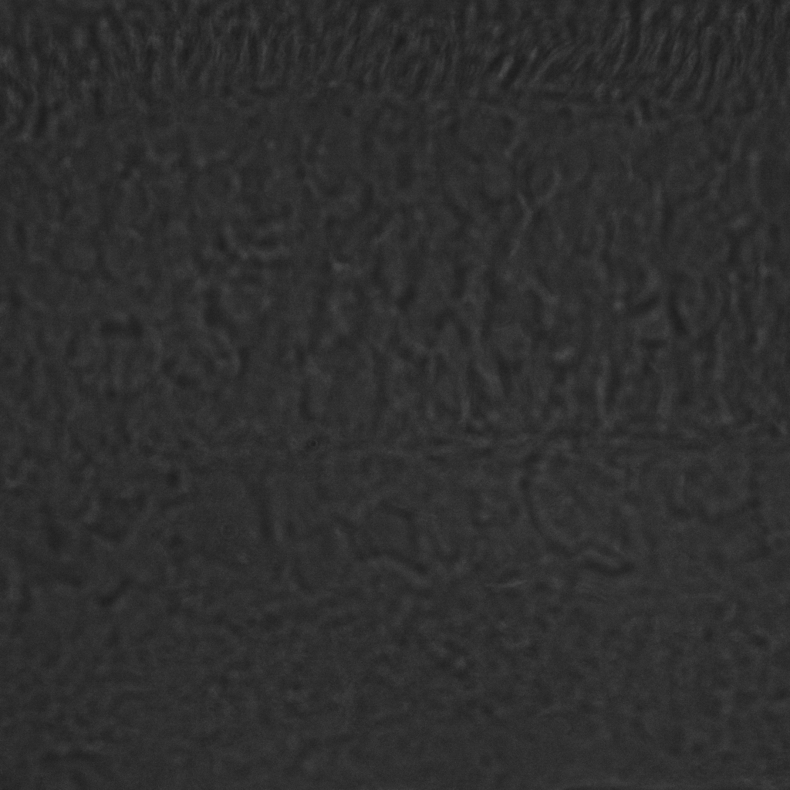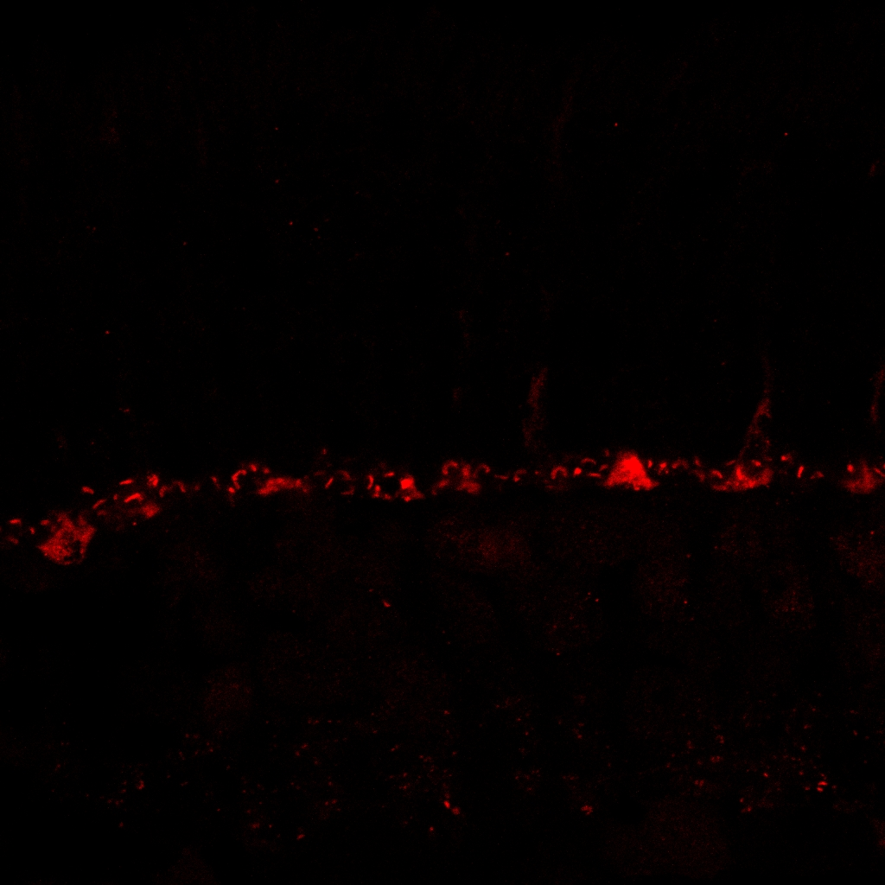
Fig.1 (left) The confocal image of the adult rabbit retina stained with Kinesin 2 (red). The dilution factor of the primary antibody is 1:400. (right) Phase contrast image of the same retinal slice. Clusters in the OPL were ribbon synapses of the cone pedicles (white arrow). Puncta of ribbon synapses appeared in the IPL. Scale bar, 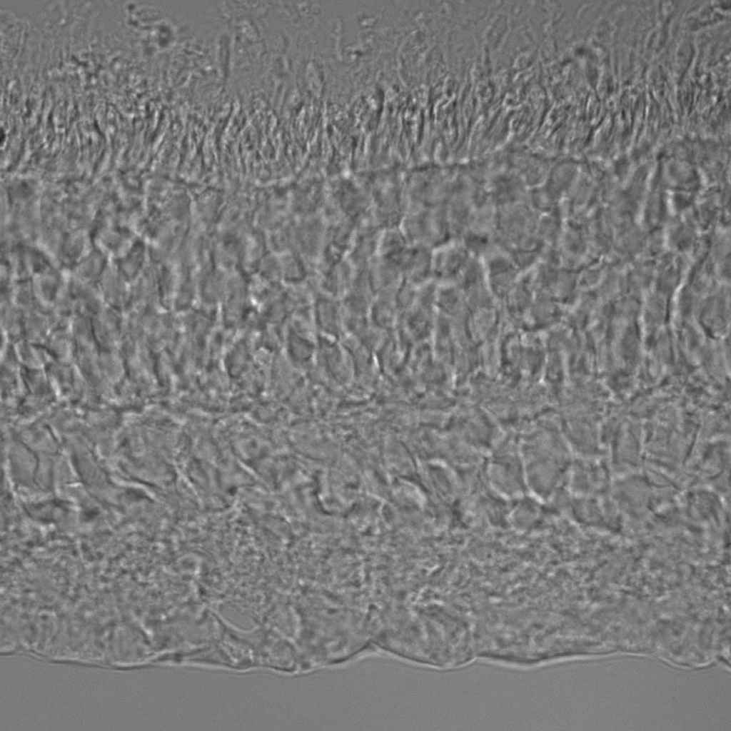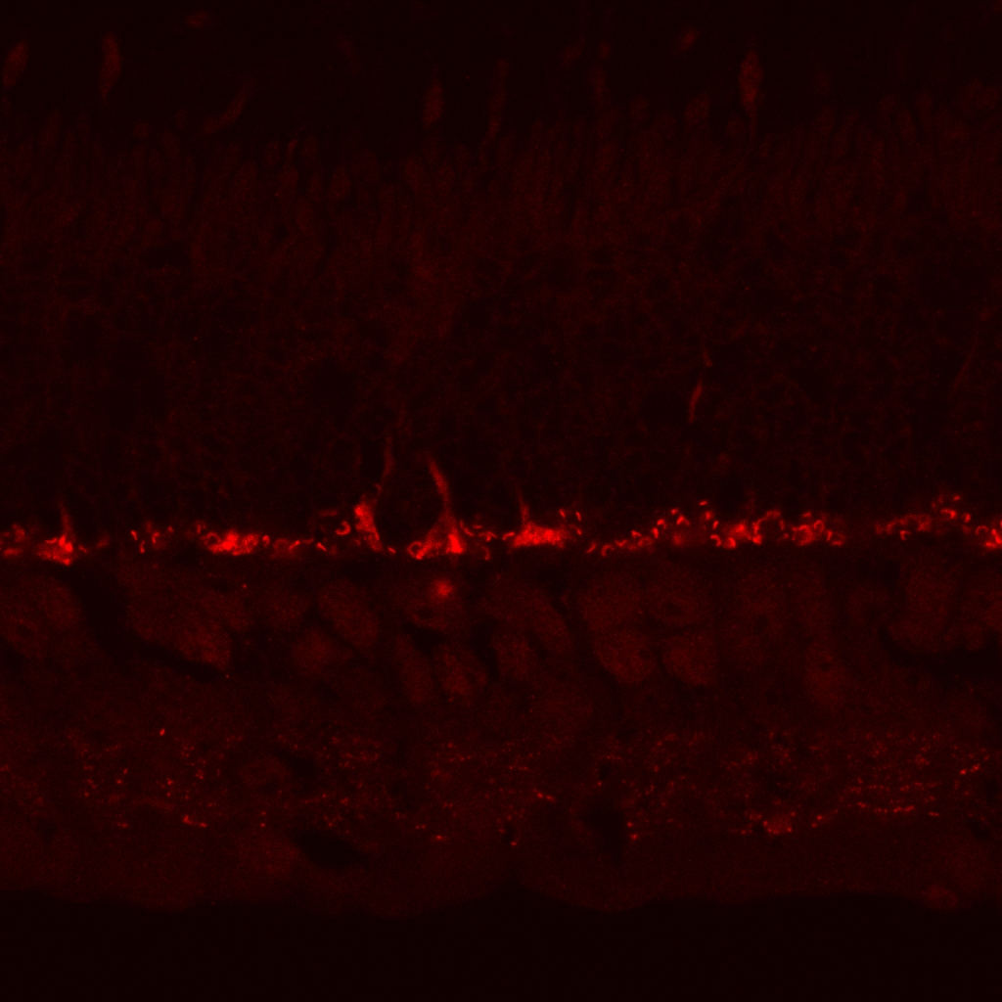
Fig.2 (left) Adult rabbit retina stained with Kinesin 2 (red). The dilution factor of the primary antibody is 1:50. (right) Phase contrast image. The rod terminals showed as the crescent shape (white arrows). Puncta of ribbon synapse showed in the OPL. Scale bar,

TIMETABLE
In the first two months, I will do immnuostaining of either single labeling or double labeling with Kinesin 2 and anti-syntaxin 1 antibodies in the adult retina, thus I will find out optimal conditions for these experiments, and learn how to use the confocal microscope. In the following four months, I will start to get retinas of all developmental stages and proceed cryosections, immunostaing, and image acquisition. In last two months, I will do data analysis and finish the final report.

ANTICIPATED RESULTS
To characterize ribbon synapses in the developing retina, I expect distinct density patterns will be observed. Ribbon synapses density of the IPL in P10-11 should be significantly less than P20-21 and adult, and there should be less difference between P20-21 and adult. The density of ribbon synapse in the OPL should follow a similar trend. In addition, by comparing the results of double labeling ribbon synapses and conventional synapses in the retina, the distinct expression patterns of the conventional synapses should also be disclosed.

GUIDANCE FROM ADVISOR

REFERENCES
Ames A, 3rd & Nesbett FB. (1981). In vitro retina as an experimental model of the central nervous system. J Neurochem 37, 867-877.
Chang YC & Chiao CC. (2008). Localization and functional mapping of AMPA receptor subunits in the developing rabbit retina. Invest Ophthalmol Vis Sci 49, 5619-5628.
Masland RH. (1977). Maturation of function in the developing rabbit retina. J Comp Neurol 175, 275-286.
McArdle CB, Dowling JE & Masland RH. (1977). Development of outer segments and synapses in the rabbit retina. J Comp Neurol 175, 253-274.
Morgans CW. (2000). Presynaptic proteins of ribbon synapses in the retina. Microsc Res Tech 50, 141-150.
Muresan V, Lyass A & Schnapp BJ. (1999). The kinesin motor KIF3A is a component of the presynaptic ribbon in vertebrate photoreceptors. J Neurosci 19, 1027-1037.
Sato S, Omori Y, Katoh K, Kondo M, Kanagawa M, Miyata K, Funabiki K, Koyasu T, Kajimura N, Miyoshi T, Sawai H, Kobayashi K, Tani A, Toda T, Usukura J, Tano Y, Fujikado T & Furukawa T. (2008). Pikachurin, a dystroglycan ligand, is essential for photoreceptor ribbon synapse formation. Nat Neurosci 11, 923-931.
Sterling P & Matthews G. (2005). Structure and function of ribbon synapses. Trends Neurosci 28, 20-29.
tom Dieck S & Brandstatter JH. (2006). Ribbon synapses of the retina. Cell Tissue Res 326, 339-346.
Wassle H. (2004). Parallel processing in the mammalian retina. Nat Rev Neurosci 5, 747-757.
Wong RO. (1990). Differential growth and remodelling of ganglion cell dendrites in the postnatal rabbit retina. J Comp Neurol 294, 109-132.

